**Hello World RESTful Web Service**

**/spring-learn/src/main/java/com/cognizant/spring_learn/controller/HelloController.java**

**package** com.cognizant.spring_learn.controller;

**import** org.slf4j.Logger;

**import** org.slf4j.LoggerFactory;

**import** org.springframework.web.bind.annotation.GetMapping;

**import** org.springframework.web.bind.annotation.RestController;

@RestController

**public** **class** HelloController {

**private** **static** **final** Logger ***LOGGER*** = LoggerFactory.*getLogger*(HelloController.**class**);

@GetMapping("/hello")

**public** String sayHello() {

***LOGGER***.info("Start sayHello");

String message = "Hello World";

***LOGGER***.info("End sayHello");

**return** message;

}

}

**Output**

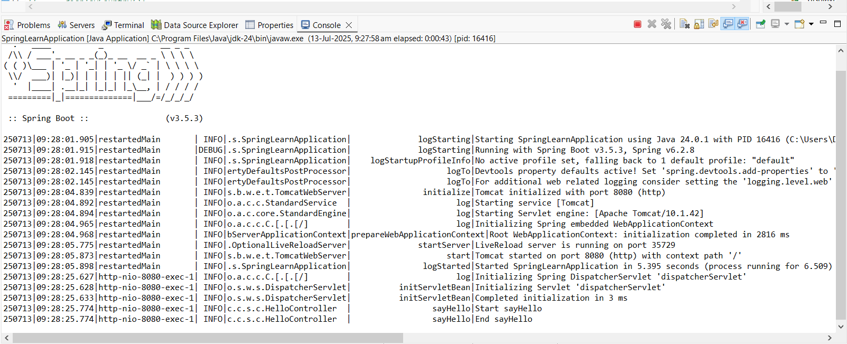

**Output** (Chrome browser)

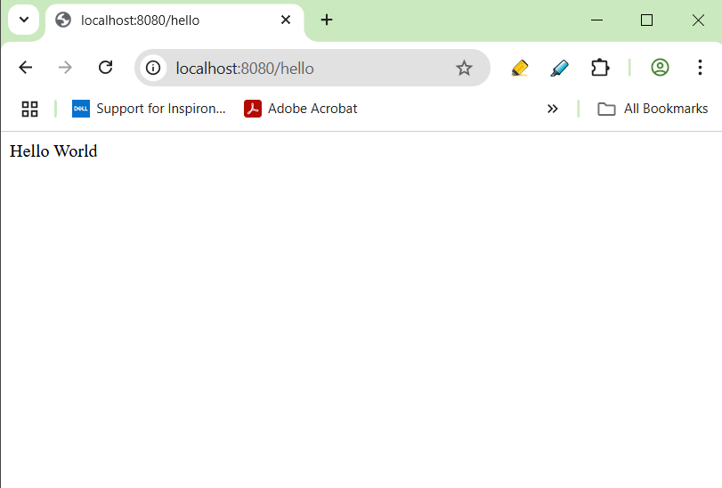

**Output** (Postman)

